**Name**: Samya Sunibir Das

**ID**: 1911563642

**Course and Section**: CSE332.3

**Submission Date**: 2nd December 2020

**Lab 4 Table and Discussion**

1. Complete the truth table of the **4-bit Universal Shift Register** from the manual

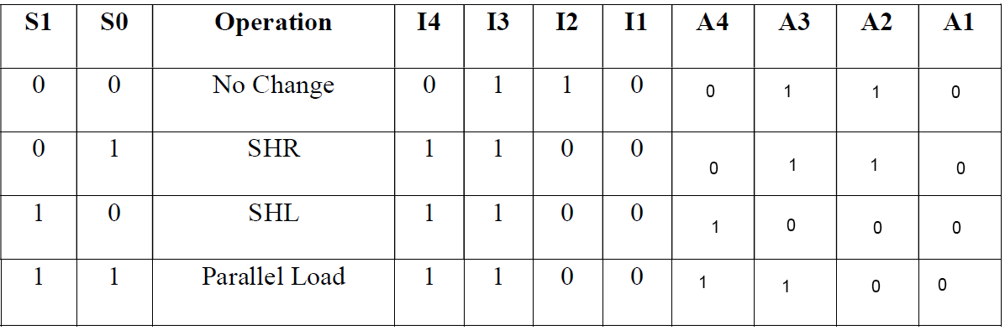

1. Discussion about the topics covered in Lab 4

In the fourth lab class, we were shown how a 4 bit Universal Shift Register works, and its processes. We learnt that when a register is able to transfer data both in

the shift-right and shift-left, along with the necessary input and output terminals for parallel

transfer, then it is called a shift register with parallel load or ‘universal shift register’. We were thoroughly demonstrated the left shift right shift processes and how individual input flows change the outputs of the circuit. We were shown with an example of a particular select bit input to complete a right shift operation on a given set of inputs. The class concluded by instructing us to submit the table and discussion in google classroom and the circuit file simulated in Logisim in git.